
Dear Member, by the time you read this we will be approaching our 6th annual conference, this year at W5, the Odyssey. If you have not reserved your place, please do so as soon as possible as it is the most prestigious event of it’s type in Ireland.  As our 6th conference, we have come a long way since the first event five years ago. FM in Ireland has changed, for example, there are now considerably more FM Contractors in Ireland with nearly every major UK or European contractor represented. In addition, every new property development has it’s own Facilities Manager and so it is heartening to see the continual growth. In Ireland, and particularly in the north, we do however have very few corporate headquarters so we must ensure that the FM industry responds to the needs of the smaller facilities and businesses. At this years conference we have set a speakers programme that we believe will enable everyone who attends, no matter the size of their organization, to leave with new ideas and initiatives that they can implement.  Believe it or not in a few months time we will start work on next years conference. A lot of work by the local committee goes into getting it right and we do appreciate feedback. So if you have something positive or negative to say, or there is a particular topic that you want to hear a presentation on, then please let us know, we will do our best to accommodate your needs.  Wilton Farrelly,  Ireland Region Chairman  wilton.farrelly@jarvis-uk.com    BT announced that it has exchanged contracts with Telereal, a 50:50 joint | venture partnership between Land  Securities Trillium and The Pears Group, for the sale of the majority of its UK property portfolio for £2.38 billion.  Completion was achieved on December 14, 2001. Around 6,700 properties will be transferred comprising offices, telephone exchanges, vehicle depots, warehouses, call centres and computer centres totaling some 5.5 million square metres. The transaction also includes the transfer of approximately 350 employees from BT Affinitis to Land Securities Trillium (Telecom) during the first quarter of 2002.  Under the terms of the agreement, Telereal will be responsible for providing accommodation and estates management services to BT. In return, BT will pay Telereal a total accommodation charge of approximately £6 per square foot including £190 million (which increases at three per cent per annum) for use of the freeholds.  BT will have the flexibility to vacate approximately 35 per cent of the estate over the contract term at no extra cost.  BT Northern Ireland’s 220 buildings, including the new HQ building Riverside Tower, are included in the deal.  Brendan Carson, BT’s Property Services Manager for Northern Ireland, said that this was the biggest ever property deal in the UK and represented an amazing opportunity for BT to effectively manage it’s property and managed services costs in partnership with a truly professional and leading edge property management company.  Warren Deal  BT | 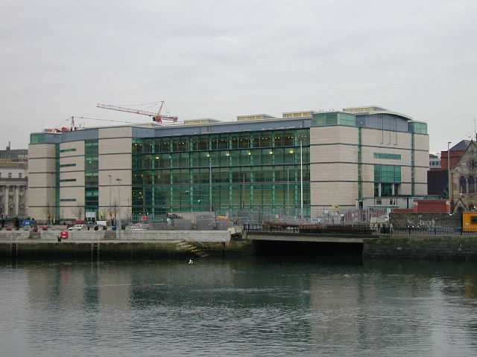  The new Laganside Courts complex has recently opened in Belfast. Built under the Private Finance Initiative this facility is managed by one of our local members, Carl  McDowell. It is a highly complex building and it is hoped that members will be able to avail of a tour around the facility in the near future. It is of course also possible for members to find themselves visiting it for other reasons……..  wilton.farrelly@jarvis-uk.com    CPD is a lifelong learning approach to planning, managing and getting the most from your own development. CPD is about what YOU need and want to help you and your business or profession. A certain amount of what you do will inevitably be led by technical or current legislation, but if, for example, you need to improve your knowledge to apply for that promotion or come to terms with new technology, then that's valid CPD. These are just two examples out of potentially hundreds.  The BIFM’s improved CPD programme that has been developed through consultation with the CPD Working Party Group and the Regional Committees will be launched on our website in March/April 02. By completing the CPD questionnaire on the BIFM website you will begin to

identify areas where you may have a weakness in your knowledge and /or experience.  CPD information will be available from Karen Ward, who will be staffing the BIFM stand at the 6th Ireland Region Conference on 22nd March. Why not make this your first step towards your CPD Programme?    Phoenix Natural Gas Ltd hosted a visit and buffet supper to members of the Ireland Branch of BIFM, to their new Operational Centre, on Tuesday 22nd January 2002 at their Operational Centre on the south eastern shores of Belfast Lough. The high degree of fenestration to the building facilitates maximum enjoyment of the stunning views of the Belfast hills and surrounding maritime features.  Day lighting, optimum window areas, sun shading, thermal mass and good insulation, together with high efficient natural gas fired boilers and heat recovery devices, all significantly contribute to conserving fuel and reducing CO2 emissions. The building has been awarded the BREEAM energy rating of “Very Good”.    The construction of the project commenced in April 2000. Occupation commenced at the end of April 2001. A phased programme was followed in order to ensure that staff were relocated as efficiently as possible with a minimum degree of disruption. Engineers, Accountants, Sales and Call Centre personnel to name but a few are strategically sited around the building so as to maximize the benefits obtained from effective space planning. | Catering facilities are provided on site by way of a self-contained restaurant facility, fuelled by natural gas – of course!  Now that Phoenix Natural Gas Ltd. have established themselves as a major force in the Northern Ireland energy marketplace, the Operational Centre will provide the business with the permanent hub it requires in order to give its customers the high standards of service that the business sets out to deliver.  Original article by  christopher.losty@phoenix-natural-gas.com  The BIFM Ireland Region would like to take this opportunity to thank Phoenix Natural Gas Ltd  for an excellent evening.  By now, you will have received the leaflet outlining the 6th BIFM (Ireland Region) Annual Conference (at a discounted registration fee for members!). The conference is an outstanding opportunity to share experiences and knowledge with many of the FM professionals across the islands that are facing the same issues as you. Why not bring a friend who has yet to see the benefits of membership that exist within the Institute? Your colleague will be entitled to participate in the 'new members' draw and you, as the sponsor will also be able to participate in a 'sponsors draw' on the day.  As a professional member of the Institute, why not pass the benefits of your expertise by arranging a visit of like mind individuals to your building? Speak to any of the Committee members for further information. | Have you moved, changed your address or phone number?  Do we have your current e-mail address?  Pass on your email to sid.seymour@virgin.net to get yourself back on to the regional distribution list. Email is faster, more cost effective and ensures that the mail goes straight to your desk. Why take the chance of missing out on what we are doing by not getting the email?  Hoping to see you all at the Conference.  Sid Seymour  sid.seymour@virgin.net  Sponsored by:  eg.information consulting, a Belfast based company delivering information technology solutions that provide  positive and tangible business benefits.  eg.information consulting are a Service Works Premium Partner for  the distribution of QFM.  QFM is a fully integrated facilities and estates management software package, which delivers measurable  cost savings, improvements in time control and boosts productivity.  For further information visit our website on www.eg-consulting.com  or the QFM website at www.serviceworks.co.uk

